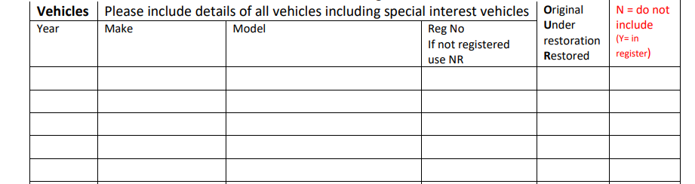
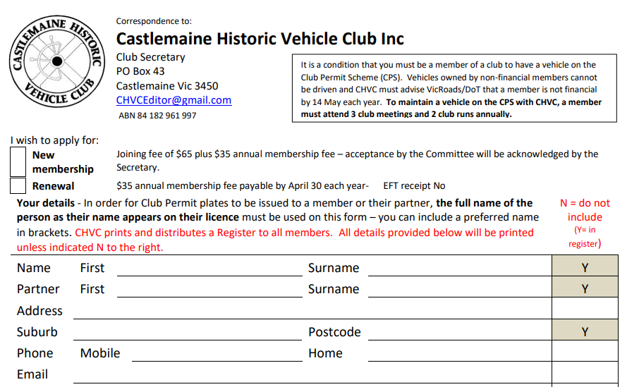
ABN 84182961997
SecretaryCHVC@gmail.com

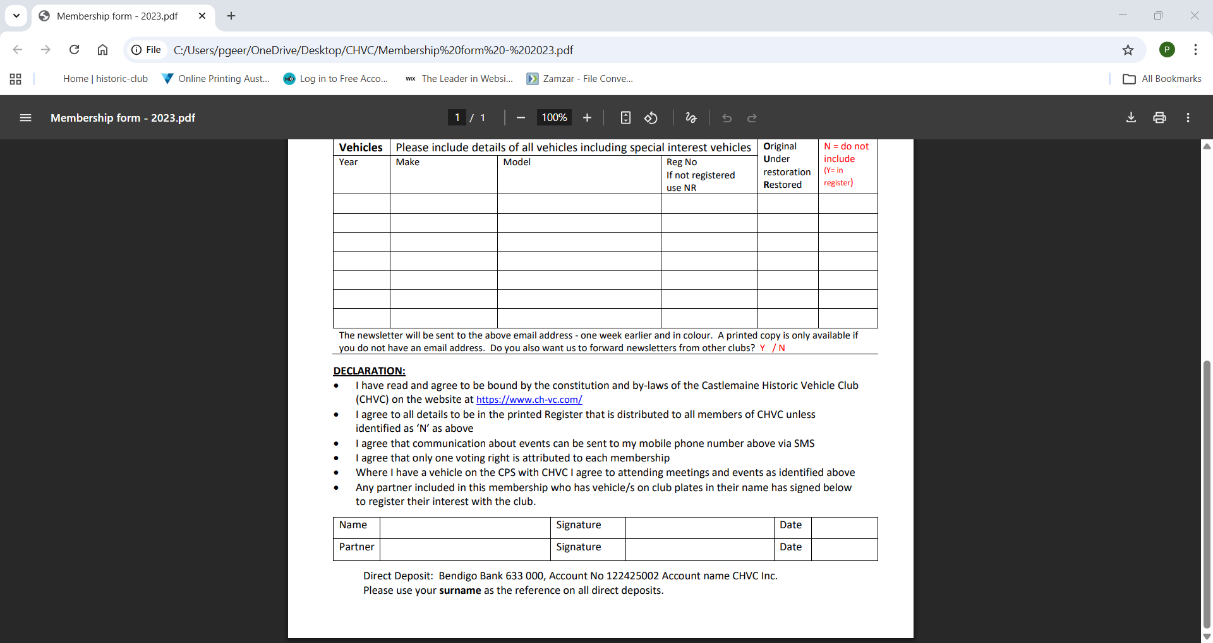

DECLARATION:
- I have read and agree to be bound by the constitution and by-laws of the Castlemaine Historic Vehicle Club (CHVC) on the website at http://www.ch-vc.com/
- I agree to all details to be printed in the printed register that is distributed to all members of CHVC unless identified as “N” as above.
- I consent to images of myself and/or my vehicle(s) for use in the newsletter, magazine or newspaper articles from time to time. Y / N
- I agree that only one voting right is attributed to each membership
- Where I have a vehicle on the CPS with CHVC I agree to attending meetings and events as identified above
- Any partner included in this membership who has vehicle/s on club plates in their name has signed below to register their interest with the club.

